## SOFTWARE DEVELOPMENT MODELS:

##### Q. What process you have used to develop your project

The models are as follows.

1. **Waterfall model**
2. **Spiral model**
3. **V-model**
4. **Fish Model**
5. **Agile process**

#### Waterfall Model:

It was the initial process or model introduced for software development (old process). The sequential execution of all the phases in SDLC is known as water fall model. Once the phase is completed, high level management will analyze that phase.

**NOTE:** How waterfalls from one level to other,in the same way the phases of SDLC will be implemented.

##### Advantages:

* + It is very easy to implement the project because it is Sequential Execution.

##### Disadvantages:

* + Therisk can't be identified at the early stage of the life cycle so it can't be prevented.
  + It is time consuming process as well as costly process.
  + We can't accept the requirements change in the middle of the project. If still needs to be accepted then we will accept the requirement change in the form of CRs-change requests.Change requests are done at the end of the project and CRs charged by the company.

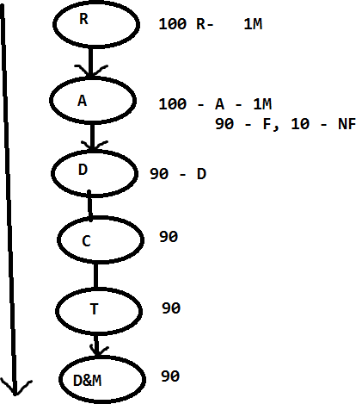

month

#### Spiral Model:

* + Spiral model is a combination of waterfall model and prototype.

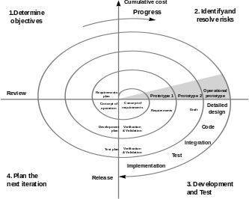

* + Instead of collecting all the requirements once, the BA collects few requirements; it will be analyzed and designed with the help of the prototype. Then it will be given to the development.
  + Once the developer develops the build then it will be released to the testing team. The same process will be continued for all the requirements.
  + Once all the requirements are completed and the build is stable, then the build will be delivered to the client.

##### Advantages:

* + We can save the time and cost, because we are executing all the phases in parallel.
  + The risk can be identified at the early stage of the SDLC and it can be prevented at the early stage of the life cycle.
  + The requirement change can be accepted at the middle of the process.

##### Disadvantages:

* + It is having the huge delivery risk, because of the aggressive time lines(less time).
  + Cannot accept requirement change at the end stage of the project to avoid delivery risk.

#### V-Model(Verification and Validation model):

##### Validation:

It is also known as “*QC” (Quality control*). The testing team is responsible for validation. Testing team will check whether the developed software is as per the client’s requirement or not.

Test engineers are validators.

##### Verification:

Def1: Check whether each and every phase outcome document is as per the company and client guidelines or not.

Def2**:**Check whether each and every role in the organization is working as per the Companies and clients guide lines or not. Verification is also known as *QA (Quality assurance).*

The project/Process management group (PMG) or audit group are responsible for verification.

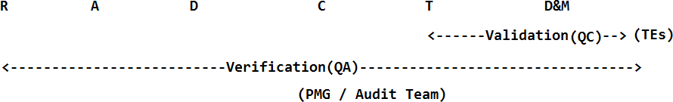

* From V-model onwards even the testing team will participate in collecting requirements.
* BA is responsible to collect the requirements,parallel the testing team will be analyzing all the requirements to check whether it is possible to test or not.
* Once the SRS is baselined, validation team is responsible for test plan
* Based on the analysis and design phases the validation team is preparing the system test plan and design plan.
* Once the code is developed they will release the build to the testing team where they will perform all the levels of testing. Once the build is stable it will be delivered to the client.

##### Advantages:

* The testing activities are started from the requirement phase onwards so that we can ensure for quality.
* For each and every phase the verification team and validation team will check the phases so that we can ensure for quality.
* The risk can be identified at the early stage because we have a parallel testing activity, so it can be prevented.
* We can accept the requirement change at the middle of the phase.

##### Disadvantages:

* It's a time consuming and costly process but we can ensure for quality.

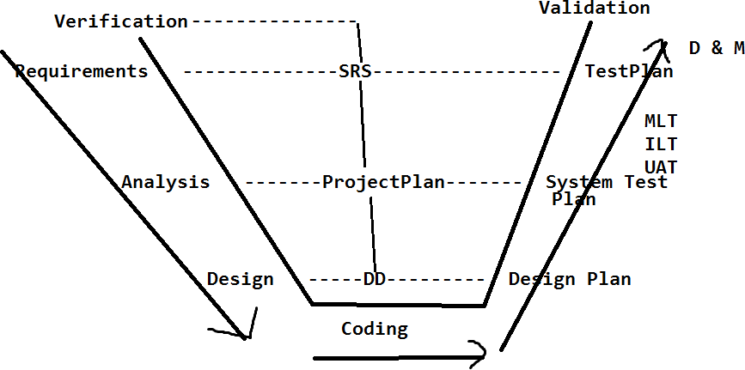

#### Fish model:

* + It is same like v-model.
  + In fish model we will have multiple Verification teams from the client and company to check the process and to provide more quality and security.
  + It is more expensive than v-model.
  + It provides more security and is applied in high level security projects like NASA, Air force, Navy, Army etc.

**Note:** Validation team will review unit test cases results when the build is under development

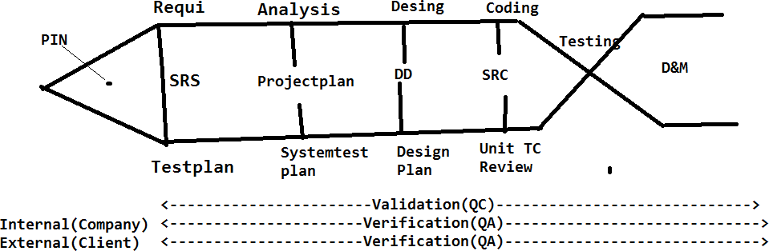

#### Agile process:

* + It is having multiple sub models like adaptive, Scrum, iterative model etc…The model which we are going to use is scrum model.
  + It is an iterative and incremental model. Scrum model is having the below activities.

1. Scrum master
2. User stories
3. Scrum meeting/scrum calls/DSM
4. Sprint plan
5. Sprint meeting
6. Backlogs

##### Scrum master:

The scrum master is, who is going to lead the project. The project manager or the client will acts as a scrum master. Scrum master is responsible for scrum meetings and sprint meetings.

##### User stories:

The requirements will be captured in the form of end user used flows (end user used ways). Hence we will call it as *User stories*. BA is responsible to collect

##### Scrum meeting:

* + On daily basis all the team members will participate in a quick meeting where they will describe what activities were performed yesterday and what tasks are planned to perform today and is there any challenges.
  + All the team members including the scrum master and client have to describe.
  + The main purpose of the scrum meeting is to track the resources and also to maintain the transparency.

##### Sprint plan:

* + Sprint is fixed time period can beone week/two weeks/three weeks etc. It will be decided by the scrum master.
  + Sprint plan is, to collectuser stories, analyze, develop, test and deliver to the client.
  + During the sprint if we are unable to complete any of the requirements the sprint won’t be extended. And the pending requirements should be carried to the next sprint. Sprint is a fixed time period

##### Sprint meeting:

Once the sprint is completed the next sprint plan will be decided under the sprint meeting. They will discuss, if the current sprint is delivered successfully or not, is there any challenges faced.

##### Backlogs:

During the sprint plan if any user stories are unable to accomplish, those will be taken as Backlogs. These backlogs have to be completed in the next sprint.

It is of two types,

1. Product Backlog
2. Sprint backlog

Product Backlog: The Requirements (user stories) which we are going to collect, develop, test and deliver it to the client as a part of sprint plan is known as *product backlogs.*

Sprint Backlog: The Requirements which are not completed as part of the sprint plan will be treated as sprint backlog.

##### Advantages:

* Each and every sprint will be tested multiple times by the testing team and client, so we can ensure for quality.
* All the phases in SDLC are performed parallel y so we can save time and cost.
* The requirement change can be accepted at any stage of the project (even after delivery of sprint).
* Risk can be identified at the early stage and it can be prevented
* We can maintain transparency of the project.
* The client will also participate in scrum meetings, so we can get the information very quickly.
* Each and every sprint is delivered to the client so we doesn’t have delivery risk.
* We can gain the customer satisfaction by delivering all the sprints to the client.
* Sprint is also known as iterative. Its and iterative and incremental model

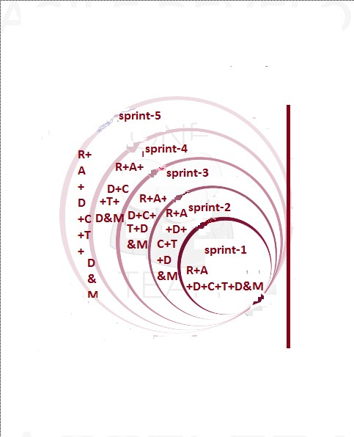

##### Disadvantages:

Maintaining all the sprint related information is a very challenging task, but we can overcome with the help of test management tools like Scrum wise, Quality center, JIRA and test link etc.